11 March 2016

Tulsa District Corps of Engineers (USACE SWT)
Attn.: Saqib Khan
1645 South 101th E Ave.
Tulsa, OK 74128-4609

Re: Preliminary Draft Revised Interim Measures Work Plan (IMWP) for the Interim Measures for Parcel 21 - Fort Wingate Depot Activity, New Mexico - Contract No. W9128F-13-D-0025, Delivery Order DS01, Modification 01

Dear Mr. Khan:

According to the FWDA submittal requirements attached are one hard copy and one electronic copy on CD of the Preliminary Draft (Army Review) IMWP for Interim Measures for Parcel 21, Fort Wingate Depot Activity, New Mexico, dated 11 Mar 2016. Additional hard copies and electronic copies on CD are also being provided to other recipients as listed below, again according to the submittal register.

If you have any questions or comments, please feel free to contact us at your convenience.

Sincerely,
Zapata Incorporated

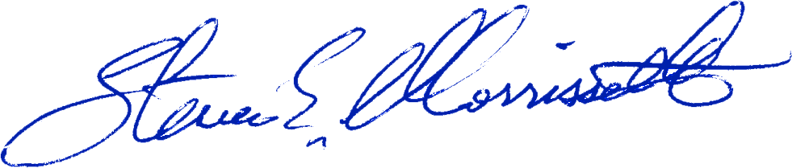
By:___ _______________________________
Steven E. Morrissette, P.G., C.P.G.
Project Manager

Distribution: Mark Patterson (FWDA BEC), one hard copy, and one copy on CD
FWDA Admin Record, one hard copy, and two copies on CD
Steve Smith (CESWF-PEC-EF), one hard copy, and two copies on CD
Admin Record – Ohio, one electronic copy on CD
Bill O’Donnell (BRACD), one electronic copy on CD

